user stories:

A project is split into several small parts called epics, which are further broken into small units, and these units are called user stories.

A user story represents a small, concise statement of functionality or quality needed to deliver value to specific stakeholders.

Simple stories that describes what the user world might look like

Building stories from user perspective.

1.User

2.Need

3.Value

User stories serve a number of key benefits:

1.A to-do list keeps the team focused on tasks that need to be checked off, but a collection of stories keeps the team focused on solving problems for real users.

2.With the end goal defined, the team can work together to decide how best to serve the user and meet that goal.

3.Stories encourage the team to think critically and creatively about how to best solve for an end goal.

4.With each passing story, the development team enjoys a small challenge and a small win, driving momentum.

How to write user stories:

Consider the following when writing user stories:

Definition of “done” — The story is generally “done” when the user can complete the outlined task, but make sure to define what that is.

Outline subtasks or tasks — Decide which specific steps need to be completed and who is responsible for each of them.

User personas — For whom? If there are multiple end users, consider making multiple stories.

Ordered Steps — Write a story for each step in a larger process.

Listen to feedback — Talk to your users and capture the problem or need in their words. No need to guess at stories when you can source them from your customers.

Time — Time is a touchy subject. Many development teams avoid discussions of time altogether, relying instead on their estimation frameworks. Since stories should be completable in one sprint, stories that might take weeks or months to complete should be broken up into smaller stories or should be considered their own epic.

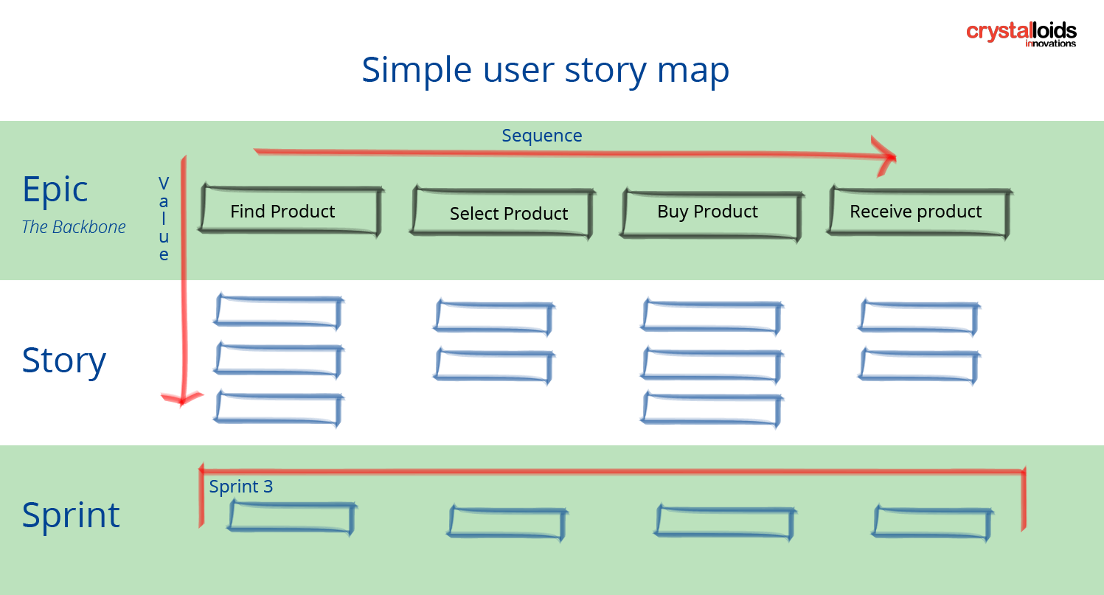

The 3 C’s of user stories:

If you’re getting started with user stories, the 3 C’s are a fun acronym that can get you started. The three Cs stand for:

Card

Conversation

Confirmation

Card is basically the actual card on which a user story is written. Prior to the remote work culture, user stories were often written on index cards so that they could be discussed, prioritized, and agreed on as a team. In remote work culture, I like to use white boarding products like Miro to create virtual cards.

Conversation is the process where you take the “cards” you wrote and share them with the team. This is where you can explain the context behind the user story, any customer research you conducted to support the user story, and why the user story is important. This is also a great time to get feedback from the rest of the development team to understand the realm of possibility, and whether you’re missing an important different perspective.

Confirmation is when you confirm that you met user requirements and needs. This confirmation is measured by whether or not the end products accomplished the acceptance criteria outlined during the conversation period and prior to development.

Live example of User story:

Share a Photo on Instagram

I want to share a recent photo from my gallery with my friends,

So that I can keep them updated on my experiences and engage with them.

Now that that I am logged into the Instagram app,

* + I navigate to the home feed,
  + I should see a "Share" button prominently displayed.

the "Share" button,

* + I click on it,
  + I should be presented with options to choose the type of content to share.

1. the content selection screen,
   * I choose "Photo" as the content type,
   * I should be able to select a photo from my device's gallery.

that I've selected a photo,

* + I click on the "Next" button,
  + I should be prompted to add a caption and tag friends if needed..

that I've shared the photo,

* + my friends log in to Instagram,
  + they should see the photo in their feed with the caption and my profile information.

that my friends see the photo,

* + they interact with it by liking or commenting,
  + I should receive notifications about their interactions.